Pumpkins
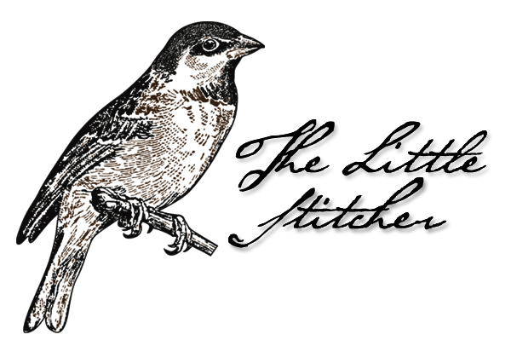

Pattern Author: Laura Rimola
Company: The Little Stitcher

Website: http://thelittlestitcher.blogspot.com
Grid Size: 38W x 37H
Design Area: 1,07" x 1,43" (15 x 20 stitches)
Model stitched on 32ct Zweigart Belfast Natural linen, aged with coffee

Stitch the design using one strand of floss over two linen threads
Backstitch with one strand of floss

Symbol guide:

( DMC 434 Topaz - ul vy dk
0 GAF 0560 Nutmeg
1 DMC 3021 Brown gray - vy dk

BackStitch Lines

DMC 3021 Brown gray - vy dk

© The Little Stitcher – 2011

